 | 
COUNCIL ASSESSMENT REPORT
HUNTER AND CENTRAL COAST REGIONAL PLANNING PANEL

PANEL REFERENCE & DA NUMBER | PPSHCC-321 – DA2024/0680
PROPOSAL | 207 Unit Seniors Housing Development
ADDRESS | Lot 343 DP 1118417  55 Marie Avenue, Taree, NSW 2430
APPLICANT | Gavin Maberly-Smith
OWNER | Bushland Health Group Ltd
DA LODGEMENT DATE | 24 September 2024
APPLICATION TYPE | Concept DA and Integrated DA
REGIONALLY SIGNIFICANT CRITERIA | Section 2, Schedule 6 of State Environmental Planning Policy (Planning Systems) 2021 : General development with a cost of works exceeding $30 million.
CIV | $ 93,571,700 (excluding GST)
CLAUSE 4.6 REQUESTS | Not applicable.
KEY SEPP/LEP | Housing SEPP, Biodiversity and Conservation SEPP, Greater Taree LEP
TOTAL & UNIQUE SUBMISSIONS KEY ISSUES IN SUBMISSIONS | Zero (0)
DOCUMENTS SUBMITTED FOR CONSIDERATION | - Attachment B – Plans  - Attachment C – Staging Plan  - Attachment D – Civil Plans  - Attachment E – Stormwater Strategy  - Attachment F – Biodiversity Development Assessment Report  - Attachment G – Bushfire Report  - Attachment H – Concept Road Work Plans  - Attachment I – Contamination Report  - Attachment J – Geotechnical Report  - Attachment K – Traffic Impact Assessment  - Attachment L – Waste Management Plan  - Attachment M – SEPP (Housing) 2021 - Schedule 4 Compliance Table
RECOMMENDATION | Approval
DRAFT CONDITIONS TO APPLICANT | YES
SCHEDULED MEETING DATE | 3 February 2026
PREPARED BY | Craig Wilkinson, Senior Development Planner,  MidCoast Council
DATE OF REPORT | 23 January 2026

EXECUTIVE SUMMARY

The development application (DA2024/0680) seeks consent for a 207 unit senior housing development. The application, being a concept application, seeks overall concept approval as well as approval of Stage 1, which includes demolition of existing structures and construction of 19 independent living units.

The subject site is known as 55 Marie Avenue, Taree (‘the site’) with two (2) road frontages including Wingham Road to the south, and Marie Avenue to the east. The site occupies a generally rectangular shaped area of 25.4Ha. Whilst the development has two (2) frontages, vehicular access to the site is via Marie Avenue.

Existing development on the site consists of a residential dwelling and ancillary structures including a detached shed and inground pool.

The site is located in an area of transition from low density residential, associated with lands to the east and south, to semi-rural towards the north and west. This area comprises predominantly low density detached dwellings. An existing seniors housing dvelopment is located directly to the east (owned by the same organisation as the proponent).

The site is located in the R1 – General Residential land zone pursuant to Clause 2.2 of the Greater Taree Local Environmental Plan 2010 (‘LEP 2010’). Seniors housing and demolition is permissible with consent in the R1 zone.

The application was exhibited from 30 September 2024 to the 6 November 2024. As a result, the application received no public submissions.
The application was referred to NSW Rural Fire Service and DPE-Water for comment as integrated development pursuant to Section 4.46 of the Act and in accordance with the Rural Fires Act 1997 and the Water Management Act 2000.
The development has been assessed against applicable State, Regional, and Local Environmental Planning Instruments and Policies, including:
- Environmental Planning and Assessment Act 1979
- Environmental Planning and Assessment Regulation 2021
- State Environmental Planning Policy (Biodiversity and Conservation) 2021
- State Environmental Planning Policy (Sustainable Buildings) 2022
- State Environmental Planning Policy (Housing) 2021
- State Environmental Planning Policy (Planning Systems) 2021
- State Environmental Planning Policy (Resilience and Hazards) 2021
- State Environmental Planning Policy (Transport and Infrastructure) 2021
- Greater Taree Local Environmental Plan 2010
- Greater Taree Development Control Plan 2010
- Greater Taree Section 94 Development Contributions Plan.

The application is referred to the Hunter and Central Coast Regional Planning Panel (‘the Panel’) as the development is ‘regionally significant development’, pursuant to Section 2.19(1) and Section 2 of Schedule 6 of State Environmental Planning Policy (Planning Systems) 2021 as the proposal is general development with a value over $30 million.

A briefing was held with the Panel on 21 January 2025. Whilst no significant issues were initially raised from the assessment, concerns were raised by the panel regarding the public interface of the development as well as inadequate arrangements for waste management. In addition to this, Councill’s development engineers also subsequently noted some concerns with insufficient details to establish if stormwater management had been appropriately addressed.

Issues associated with the proposal included:

- Streetscape and interface to adjoining properties - The development initially lacked sufficient details to establish the impacts on the streetscape and interfaces with adjoining properties. The applicant provided additional details, including streetscape and property boundary sections as well as conceptual details for all independent living units for the proposal. The submission of these details demonstrated that the application was acceptable having regards for the issues raised.
- Stormwater Management – Concerns were raised by Council’s Development Engineering team in relation to stormwater management associated with the proposal. Additional details were sought form the applicant to address these concerns. The additional information was assessed by Council and deemed to be appropriate to satisfy the concerns. Conditions of consent have been imposed relating to stormwater detail design.
- Waste Management – The Planning Panel raised concerns with the level of detail provided in association with waste management associated with the site. In relation to this, the applicant provided a detailed waste management plan, which was completed in consultation with Council’s Waste Management team. Subsequently, the plan was reviewed by Council’s Waste Services team and supported.

The principal planning controls relevant to the proposal include State Environmental Planning Policy (Housing) 2021 (‘SEPP Housing’), the Greater Taree Local Environmental Plan 2010 (‘LEP’) and the Greater Taree Development Control Plan (‘DCP’). The proposal is consistent with the relevant provisions of the planning controls

Following consideration of the matters for consideration under Section 4.15(1) of the EP&A Act, the provisions of the relevant State environmental planning policies, it is considered that the proposal can be supported.

Following a detailed assessment of the proposal, pursuant to Section 4.16(1)(b) of the EP&A Act, DA2024/0680 is recommended for approval subject to the conditions contained in Attachment A of this report.

- THE SITE AND LOCALITY

  - The Site

The subject site is identified as Lot 343 DP 1118417, being known as 55 Marie Avenue, Taree. With an area of 25.4Ha, the site is generally rectangular, with a boundary along the southern side which wraps around the adjacent residential properties. The subject site is located approximately 4.5km from the Taree CBD.

The site has a minor frontage to Wingham Road to the south with the predominant frontage being to Marie Avenue along the eastern side. There is scattered vegetation located across the site, however this is predominantly concentrated in the north-eastern corner. There is also a water course which dissects the site from the north-western corner across to the western boundary.

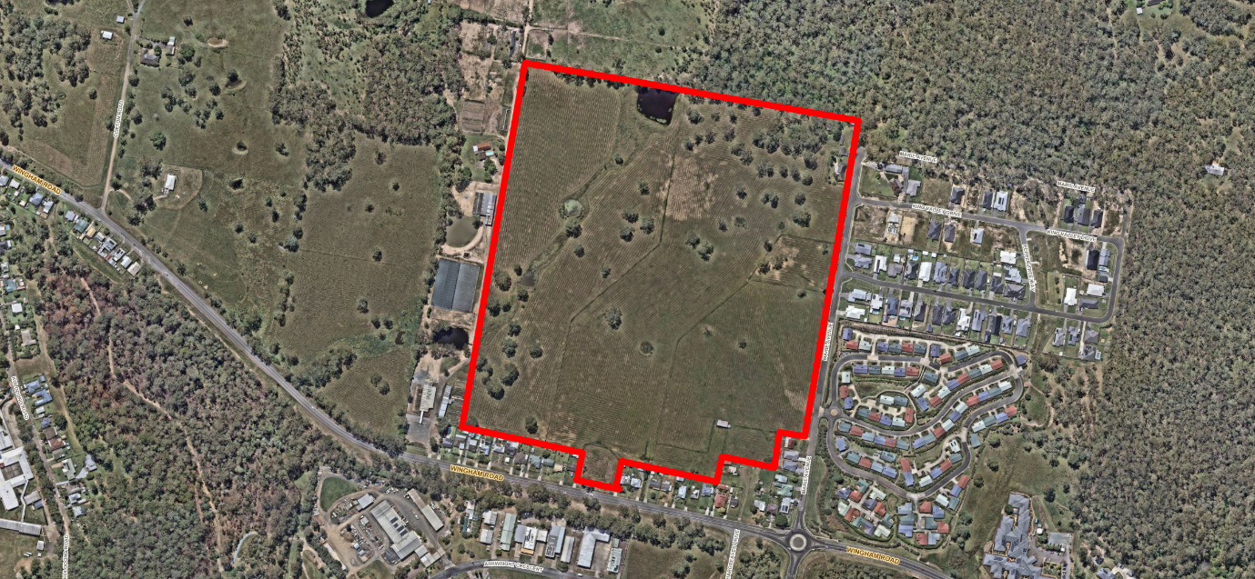
Figure 1: Site Aerial Imagery

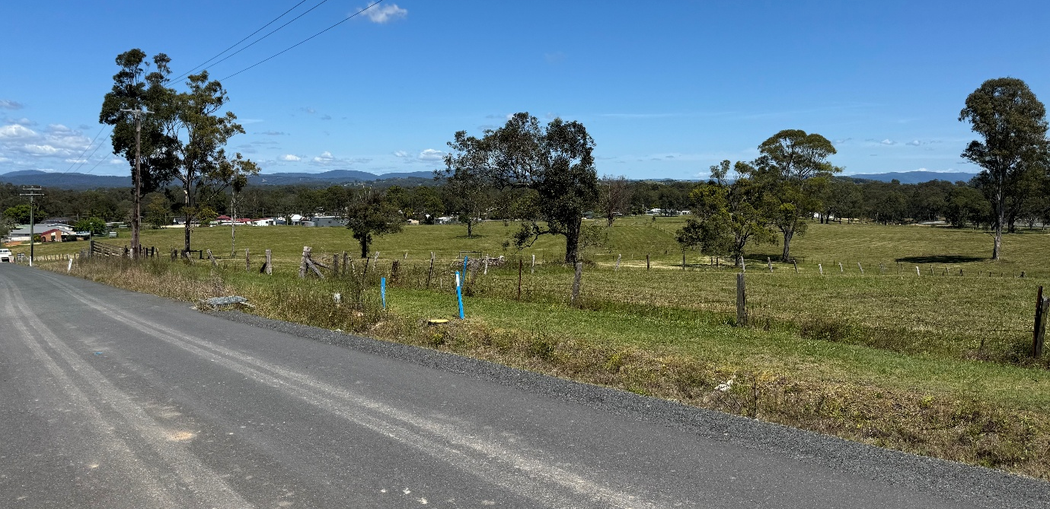
Figure 2: View of the site form the top of Marie Avenue

  - The Locality

The locality surrounding the development site is a mixture of residential dwellings (to the south, and east and semi-rural properties to the north and west. There is an industrial precinct located further to the south of the site beyond the residential dwellings. The dwellings surrounding the site are typically detached dwellings of a low density.

The site is located on the outer fringe of Taree on Wingham Road. It is noted that there is a seniors housing development adjacent to the site (to the east) which is operated by the same owner as the subject site.

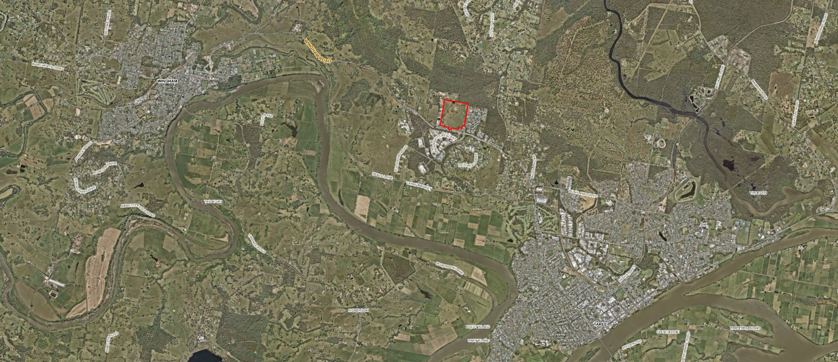
Subject Site
Wingham
Taree

- THE PROPOSAL AND BACKGROUND

  - The Proposal

The application proposes a seniors housing development, which includes 207 independent living units, as well as communal spaces and facilities. The proposal includes two access points from Marie Avenue, with no direct vehicle access form Wingham Road. The independent living units will be serviced by internal access roads which traverse the site.

To facilitate the proposal, the existing dwelling and ancillary structures will be demolished.

The development is intended to be delivered in stages as a concept application. The application involves concept approval for the proposal along with approval of Stage 1 works, being 19 independent units, demolition of existing structures, vegetation removal and bulk earthworks for the site.
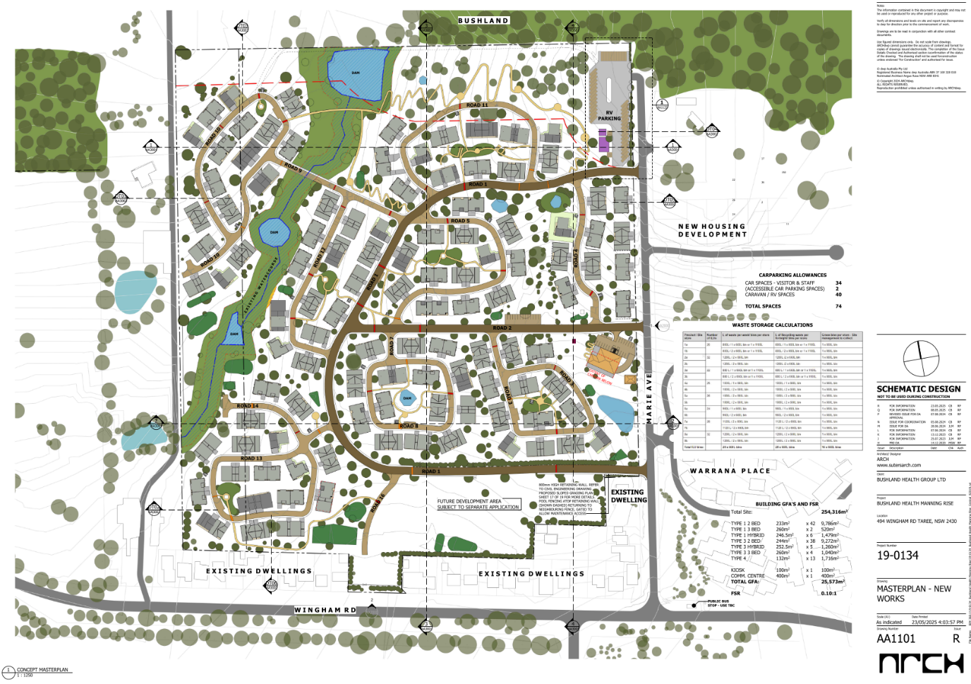
Figure 3: Development Concept Layout

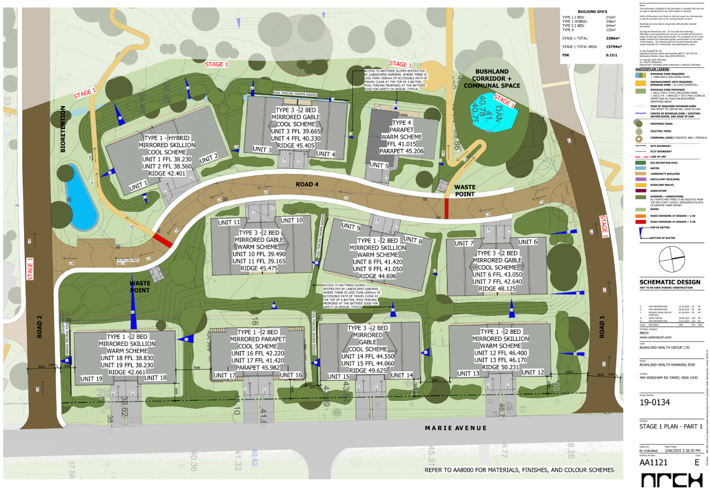
Figure 4: Stage 1 Component of Development
Table 1: Development Data
Control | Proposal
Site area | 254,316m2
GFA | 25,573m2
FSR (retail/residential) | 0.10:1
Clause 4.6 Requests | Yes/No – specify
No of independent living units | 207 units (19 in Stage 1)
Max Height | 5.1m
Landscaped area | 65% of site area.

  - Background

A pre-lodgement meeting was held prior to the lodgement of the applicant on 30 August 2022 where various issues were discussed. A summary of the key issues raised are outlined below:

- No vehicle access to the site directly from Wingham Road
- Low scale development is encouraged.
- Built form, landscaping treatments and fencing should be considered to assist in reducing visual impacts.
- Consideration of impacts to environmental sensitive areas of the site and watercourse

The above matters are considered to have been incorporated in the application that has been submitted.

The development application was lodged on 24 September 2024. A chronology of the development application since lodgement is outlined below including the Panel’s involvement (briefings, deferrals etc) with the application:

Table 2: Chronology of the DA
Date | Event
24 September 2024 | DA lodged
30 September 2024 | Exhibition of the application
30 September 2024 | DA referred to external agencies
21 January 2025 | Panel briefing
10 March 2025 | Request for Information from Council to applicant
3 June 2025 | Additional details lodged. The applicant submitted details in response to the request for information. The response did not include the engineering details that were requested.
25 June 2025 | Meeting was held between applicant, the applicants engineer and Council to discuss the requirements of the outstanding engineering request for information.
30 October 2025 | Additional details lodged. The applicant submitted the final engineering details in response to the request for information.

  - Site History

The site appears to have historically been maintained as a large semi-rural property and contains a single residential dwelling and ancillary structures.

The site was previously subject of a 254 lot staged residential subdivision, which was approved through 254/2005/DA on 8 December 2005. On 5 May 2009 Council issued a letter to the applicant advising them that physical commencement had been achieved for 254/005/DA based on preliminary works being completed.

The proposed subdivision, which has not progressed, is shown in the below extract:

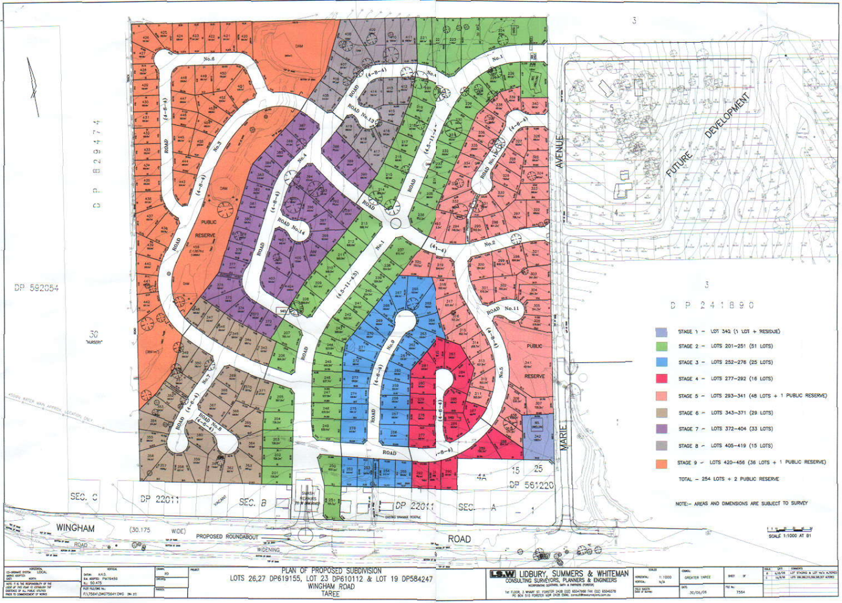
Figure 5: Layout of approved subdivision 254/2005/DA

- STATUTORY CONSIDERATIONS

When determining a development application, the consent authority must take into consideration the matters outlined in Section 4.15(1) of the Environmental Planning and Assessment Act 1979 (‘EP&A Act’). These matters as are of relevance to the development application include the following:

- the provisions of -
(i) any environmental planning instrument, and
(ii) any proposed instrument that is or has been the subject of public consultation under this Act and that has been notified to the consent authority (unless the Planning Secretary has notified the consent authority that the making of the proposed instrument has been deferred indefinitely or has not been approved), and
(iii) any development control plan, and
(iiia) any planning agreement that has been entered into under section 7.4, or any draft planning agreement that a developer has offered to enter into under section 7.4, and
(iv) the regulations (to the extent that they prescribe matters for the purposes of this paragraph),
that apply to the land to which the development application relates,
- the significant likely impacts of that development, including environmental impacts on both the natural and built environments, and social and economic impacts in the locality,
- the suitability of the site for the development,
- any submissions made in accordance with this Act or the regulations,
- the public interest.

These matters are further considered below.

It is noted that the proposal is considered to be (which are considered further in this report):

- Integrated Development (s4.46)

  - Environmental Planning Instruments, proposed instrument, development control plan, planning agreement and the regulations

The relevant environmental planning instruments, proposed instruments, development control plans, planning agreements and the matters for consideration under the Regulation are considered below.

- Section 4.15(1)(a)(i) - Provisions of Environmental Planning Instruments

The following Environmental Planning Instruments are relevant to this application:

- State Environmental Planning Policy (Biodiversity and Conservation) 2021
- State Environmental Planning Policy (Sustainable Buildings) 2022
- State Environmental Planning Policy (Housing) 2021
- State Environmental Planning Policy (Planning Systems) 2021
- State Environmental Planning Policy (Resilience and Hazards) 2021
- State Environmental Planning Policy (Transport and Infrastructure) 2021
- Greater Taree Local Environmental Plan 2010

A summary of the key matters for consideration arising from these State Environmental Planning Policies are outlined in Table 3 and considered in more detail below.

Table 3: Summary of Applicable Environmental Planning Instruments
EPI | Matters for Consideration | Comply (Y/N)
State Environmental Planning Policy (Biodiversity & Conservation) 2021 | Chapter 4: Koala Habitat Protection 2021 | Y
State Environmental Planning Policy (Sustainable Buildings) 2022 | No compliance issues identified subject to imposition of conditions on any consent granted. | Y
State Environmental Planning Policy (Housing) 2021 | Chapter 3: Diverse Housing  Part 5 – Housing for Seniors and People with a Disability. | Y
State Environmental Planning Policy (Planning Systems) 2021 | Chapter 2: State and Regional Development  - Section 2.19(1) declares the proposal regionally significant development pursuant to Section 2 of Schedule 6 as it comprises general development with a value over $30 million. | Y
SEPP (Resilience & Hazards) | Chapter 4: Remediation of Land  - Section 4.6 - Contamination and remediation has been considered in the Contamination Report and the proposal is satisfactory subject to conditions. | Y
State Environmental Planning Policy (Transport and Infrastructure) 2021 | Chapter 2: Infrastructure  - Section 2.119(2) - Development with frontage to classified road. | Y
Greater Taree Local Environmental Plan 2010 | Part 2  Part 4  Part 5  Part 7 | Y

Consideration of the relevant SEPPs is outlined below:

State Environmental Planning Policy (Biodiversity and Conservation) 2021

The provisions of SEPP (Biodiversity and Conservation) 2021 are applicable to the MidCoast local government area, and therefore, consideration of the impacts on the Koala habitat must be undertaken. An assessment of the presence of koala tree species and core koala habitat was undertaken by the applicant. This assessment noted that whilst there was koala use tree species on the site, there was no evidence of any usage recorded on the site.

The report identified that the subject development involves the clearing of native vegetation within potential koala habitat and is not considered low impact. Accordingly, a Koala Assessment Report was undertaken for the proposal.
The supplied assessment concluded that the proposal will not result in significant impact on koala habitat and would not significantly affect the recovery or expansion of koalas in the area. The assessment noted that mitigation and management practices should be implemented to assist in reducing potential impacts (nominated as mitigation measures within the Biodiversity Development Assessment Report).
These matters have been reviewed and confirmed by Councils Ecology team. Conditions of consent have also been imposed to ensure compliance with the mitigation measures.

State Environmental Planning Policy (Sustainable Buildings) 2022

State Environmental Planning Policy (Sustainable Buildings) 2022 (‘BASIX SEPP’) applies to the proposal. The objectives of this Policy are to ensure that the performance of the development satisfies the requirements to achieve water and thermal comfort standards that will promote a more sustainable development.

The application is accompanied by a BASIX Certificate committing to environmentally sustainable measures. The Certificate demonstrates the proposed development satisfies the relevant water, thermal and energy commitments as required by the BASIX SEPP. The proposal is consistent with the BASIX SEPP subject to the recommended conditions of consent.

State Environmental Planning Policy (Housing) 2021

The development proposes Seniors Housing (Independent Living) and has been lodged under the provisions of Chapter 3, Part 5 (Housing for Seniors and People with a Disability) of State Environmental Planning Policy (Housing) 2021 (SEPP (Housing) 2021). In accordance with Sections 79, 80 and 81, the development is located on land to which Part 5 applies (not excluded by any provision of Section 80) and is permitted with consent (being the subject of this assessment).

Division 3 Development standards:

Division 3 provides a series of development standards which must be addressed as part of any application for Seniors Housing. An assessment against the relevant standards is provided below (Note: those sections which are not relevant or not applicable have been excluded from the table):

Section 84 - Development Standards - General
Subclause | Comment
(1) This section applies to development for the purposes of seniors housing involving the erection of a building. | Noted. The development involves the erection of buildings.
(2) Development consent must not be granted for development to which this section applies unless—  (a) the site area of the development is at least 1,000m², and  (b) the frontage of the site area of the development is at least 20m measured at the building line, and  (c) for development on land in a residential zone where residential flat buildings are not permitted—  (i) the development will not result in a building with a height of more than 9.5m, excluding servicing equipment on the roof of the building, and  (ii) if the roof of the building contains servicing equipment resulting in the building having a height of more than 9.5m—the servicing equipment complies with subsection (3), and  (iii) if the development results in a building with more than 2 storeys—the additional storeys are set back within planes that project at an angle of 45 degrees inwards from all side and rear boundaries of the site. | The development complies with the relevant parts as noted:.  - The site has an area greater than 1,000m².  - the frontage exceeds the minimum 20m requirement.  - The land associated with the development does not permit residential flat buildings. Accordingly, the development proposes buildings which are all lower than 9.5m (maximum under Stage 1 is 5.1m).  No service equipment is proposed for any structure under Stage 1, however may be proposed under future stages. Notwithstanding this, it is considered that this any future building will be capable of being retained below the requirements and not exceed the 9.5m.  No two-storey structures are proposed.
Section 85 - Development Standards for Hostels and Independent Living Units
Subclause | Comment
(1) Development consent must not be granted for development for the purposes of a hostel or an independent living unit unless the hostel or independent living unit complies with the relevant standards specified in Schedule 4. | An assessment of the development against the standards prescribed in Schedule 4 has been undertaken and the units are considered to be compliant with the standards specified.  It is noted that a number of the standards prescribed relate to construction matters. Whilst being able to establish that the development is capable of complying with these standards, it is difficult to establish definitive compliance as construction specifications are not required for a development application. Notwithstanding this, it is accepted that the development is capable of complying with all standards.  To ensure that compliance is achieved, conditions of consent are to be imposed to require the development to conform with all standards and requirements prescribed with Schedule 4.
(2) An independent living unit, or part of an independent living unit, located above the ground floor in a multi-storey building need not comply with the requirements in Schedule 4, sections 2, 5–13 and 15–21 if the development application is made by, or by a person jointly with, a social housing provider or Landcom. | Not applicable – no multi-storey buildings are proposed.
Section 88 - Restrictions on occupation of seniors housing
Subclause | Comment
(1) Development permitted under this Part may be carried out for the accommodation of only the following—  (a) seniors or people who have a disability,  (b) people who live in the same household with seniors or people who have a disability,  (c) staff employed to assist in the administration and provision of services to housing provided under this Part. | The applicant has identified that the intent of the development is to cater for the following:  “As per the provisions of clause 88 of the SEPP, the occupation of the proposed dwellings is restricted to persons who are seniors (60 years and over), persons with a disability, members of the household and any live-in staff/managers.” (SEE, pp 29).
(2) Development consent must not be granted under this Part unless the consent authority is satisfied that only the kinds of people referred to in subsection (1) will occupy accommodation to which the development relates. | Council is satisfied that the development will be restricted to those occupants listed in Subsection (1).

Division 4 Site-related requirements

Division 4 provides a series of site related requirements which must be addressed as part of any application for Seniors Housing. An assessment against the relevant requirements is provided below (Note: those sections which are not relevant or not applicable have been excluded from the table):

Section 93 - Location and access to facilities and services—independent living units
Subclause | Comment
(1) Development consent must not be granted for development for the purposes of an independent living unit unless the consent authority has considered whether residents will have adequate access to facilities and services—  (a) by a transport service that complies with subsection (2), or  (b) on-site.  Note: The additional details of subclauses (2)-(5) are not reproduced in this table, however are addressed as part of the response to subclause (1). | Council has considered the provision of appropriate access to facilities and services associated with the development. With regards for this it is considered that the development provides an appropriate mix of access options for residents. To this extent the following is noted:  - The site has access to a transport service (bus stop) located along Wingham Road, which has a service to and from the Taree CBD once daily (weekdays only) – Service provided by Eggins Comfort Coaches – Route 319 with a stop indicated at Mayo Hospital, Wingham Road and Alma Place, Wingham Road as designated stops (current as of 13 January 2026).  - The access pathway to the bus stop is within 400m of the site. The pathway, to the lowest point of the site has a gradient of 1:17.5m, which satisfies the gradient requirements.  - The applicant has indicated that some minor services will be provided on site, including a café and some recreational spaces, as well as an area for medical practitioners (Note: medical practitioner not identified as a permanent arrangement).  - As the development is regional and not located in one of the prescribed areas for excluding on-demand booking services, it is also noted that the site is accessible by taxi services, community transport as well as ride share services.  As noted above, it is demonstrated that the site is accessible for residents to travel to and from the site to areas where essential services and facilities are located. This is considered to satisfy the requirement of Section 93.
Section 95 - Water and sewer
Subclause | Comment
(1) A consent authority must not consent to development under this Part unless the consent authority is satisfied the seniors housing will—  (a) be connected to a reticulated water system, and  (b) have adequate facilities for the removal or disposal of sewage. | Council is satisfied that the development will be connected to a reticulated water supply as well as being serviced by an appropriate sewage network.  Council’s Water Services team have provided support for the development noting that there is sufficient capacity within both the water and sewage networks to cater for the proposal.
Section 96 – Bush fire prone land
Subclause | Comment
(1) A consent authority must not consent to development under this Part on relevant bush fire prone land unless the consent authority is satisfied the development complies with the requirements of Planning for Bushfire Protection. | As the land is identified as being bushfire prone land, the development was referred to NSW Rural Fire Services in accordance with Section 100B of the Rural Fires Act 1997 as a special fire protection purpose.  A bushfire safety authority has been issued by NSW Rural Fire Service which notes that the development conforms to the requirements of Planning for Bushfire Protection.  Based on concurrence being issued by NSW Rural Fire Service, Council is satisfied that the development complies with Planning for Bushfire Protection.
(2) In determining a development application for development under this Part on land near relevant bush fire prone land, the consent authority must—  (a) consult with the NSW Rural Fire Service and consider its comments, and  (b) consider the following including—  (i) the location of the development,  (ii) the means of access to and egress from the location,  (iii) the size of the existing population within the area,  (iv) age groups within the population and the number of persons within the age groups,  (v) the number of hospitals and other facilities providing care to the residents of the facilities within the area, and the number of beds within the hospitals and facilities,  (vi) the number of schools within the area and the number of students at the schools,  (vii) existing seniors housing within the area,  (viii) the road network within the area and the capacity of the road network to cater for traffic to and from existing development if there were a need to evacuate persons from the area in the event of a bush fire,  (ix) the adequacy of access to and from the site of the development for emergency response vehicles,  (x) the nature, extent and adequacy of bush fire emergency procedures that can be applied to the development and its site,  (xi) the requirements of Fire and Rescue NSW. | As per Subclause (1) above, concurrence has been received from NSW Rural Fire Service. All comments and conditions required by NSW Rural Fire Service have been incorporated into this assessment.  Based on concurrence being provided and a bushfire safety authority being issued, council is satisfied that the matters prescribed in Subclause (2)(b) have been appropriately considered.

Division 5 Design requirements

Division 5 provides design requirements which must be addressed as part of any application for Seniors Housing. An assessment against the relevant requirements is provided below:

Section 97 - Design of seniors housing
Subclause | Comment
(1) In determining a development application for development for the purposes of seniors housing, a consent authority must consider the Seniors Housing Design Guide, published by the Department in December 2023. | A review of the development against the relevant design principles and guidelines contained within the Seniors Housing Design Guide has been undertaken.  This review has identified that the development is satisfactory having regards for the relevant maters prescribed within the guide and can be supported.  Separate assessment against the guide is provided elsewhere in this report.
(2) Development consent must not be granted to development for the purposes of seniors housing unless the consent authority is satisfied the design of the seniors housing demonstrates that adequate consideration has been given to the design principles for seniors housing set out in Schedule 8. | A review of the development against the relevant design principles contained within Schedule 8 has been undertaken.  This review has identified that the development is satisfactory having regards for the relevant maters prescribed within the schedule and can be supported.  Separate assessment against Schedule 8 is provided elsewhere in this report.

Division 7 Non-discretionary development standards.

Division 7 provides a series of non-discretionary development standards which must be addressed as part of any application for Seniors Housing. An assessment against the relevant requirements is provided below (Note: those sections which are not relevant or not applicable have been excluded from the table):

Section 108 - Non-discretionary development standards for independent living units—the Act, s 4.15
(2) The following are non-discretionary development standards in relation to development for the purposes of independent living units—
Subclause | Comment
(a) no building has a height of more than 9.5m, excluding servicing equipment on the roof of a building, | The development does not involve the erection of any building which has a height exceeding 9.5m.  All residential units are single storey and typically range in height between 4.0 – 5.5m. The highest structure within the overall development is the community centre which has a ridge height of 7.3m, which remains below the permitted 9.5m.  All Stage 1 residential units are no higher than 5.1m, which again, is below the 9.5m threshold.
(b) servicing equipment on the roof of a building, which results in the building having a height of more than 9.5m—  (i) is fully integrated into the design of the roof or contained and suitably screened from view from public places, and  (ii) is limited to an area of no more than 20% of the surface area of the roof, and  (iii) does not result in the building having a height of more than 11.5m, | As per above, no structure is above 9.5m. No residential unit is proposed to have service equipment located on the roof. Even if it were to be located on the roof, it is unlikely to result in the units exceeding the 9.5m height threshold.  The design details for Stage 1 do not propose any service equipment on the roof of any structure.
(c) the density and scale of the buildings when expressed as a floor space ratio is 0.5:1 or less, | The density of the development is below the maximum threshold. The floor space ratio for the development is 0.10:1, which is below the maximum permitted 0.5:1.
(d) a minimum landscaped area that is the lesser of—  (i) 35m² per dwelling, or  (ii) 30% of the site area, | The development provides a total landscaped area of 65% of the total site area. This is above the minimum requirement of 30% of the total site area.
(e) (Repealed) | Not applicable – repealed.
(f) a deep soil zone on at least 15% of the site area, where each deep soil zone has minimum dimensions of 3m and, if practicable, at least 65% of the deep soil zone is located at the rear of the site, | The development provides a total landscaped area of 65%, all of which is capable of deep soil planting. Based on this, the deep soil zone for the site is 65% of the site, which exceed the required coverage of 15% of the total site area.
(g) at least 70% of the dwellings receive at least 2 hours of direct solar access between 9am and 3pm at mid-winter in living rooms and private open spaces, | All units within the development achieve the minimum required solar access of 2 hours between 9am and 3pm at mid winter.
(h) for a dwelling in a single storey building or a dwelling located, wholly or in part, on the ground floor of a multi-storey building—  (i) at least 15m² of private open space per dwelling, and  (ii) at least 1 private open space with minimum dimensions of 3m accessible from a living area located on the ground floor, | All units are considered to be capable of providing the minimum required private open space of 15m² and minimum dimensions of 3.0m.  The detail plans for stage 1 indicate that each unit does comply with these requirements. All units are provided with multiple outdoor private open spaces which all exceed the minimum required 15m² and all have minimum dimension of 3.0m (all exceed this requirement).
(i) for a dwelling in a multi-storey building not located on the ground floor—a balcony accessible from a living area with minimum dimensions of 2m and—  (i) an area of at least 10m², or  (ii) for each dwelling containing 1 bedroom—an area of at least 6m², | Not Applicable.  Notes: There are no multi-storey units or multistorey buildings within the development.
(j) for a development application made by, or made by a person jointly with, a social housing provider or Landcom—at least 1 parking space for every 5 dwellings, | Not Applicable.  Notes: The development application is not made jointly with a social housing provider or Landcom.
(k) if paragraph (j) does not apply—at least 0.5 parking spaces for each bedroom. | The development exceeds the minimum requirements for parking. Each two-bed unit has a one (1) parking space and each three-bed unit has two (2) parking spaces.

Schedule 4 Standards concerning accessibility and usability for hostels and independent living units

An evaluation against the accessibility and usability standards as prescribed in Schedule 4 is provided below:

Part 1 Standards applying to hostels and independent living units

Siting Standards

The applicant has demonstrated that the development conforms to the requirements of AS1428.1 for access. Based on this, it is taken that each dwelling has wheelchair access by a continuous accessible path of travel. This has been demonstrated within the plan set for Stage 1 which shows detail design for access paths which comply with AS1428.1. Further to this, the civil plans show that appropriate gradients can be achieved across the whole site. Further consideration of this will be required at later stages, however it appears that it can conceptually achieve compliance.

Letterboxes

Details not specifically provided at this stage, however a review of the plans and details indicates that this is capable of being complied with and each unit is capable of having it’s own letterbox.

Car Parking

Each unit is provided with at least one parking space which has a minimum width of 4.06m. This exceeds the minimum requirements of 3.2m wide (with the capability of being enlarged to 3.8m) and 2.5m high.

Whilst additional parking is proposed throughout the development, this is intended as visitor parking only and not for the use by occupants of the units.

Accessible Entry

The applicant has noted that the development has been designed in accordance with AS1428.1. A review of the plans for the units associated with Stage 1 indicates that the entry ways are compliant with the requirements of AS1428.1, with an open width of 1.0m. Conditions of consent requiring the buildings to be complaint with AS1428.1 will be imposed.

Interiors

The plans and details for Stage 1 units indicate that the units are capable of achieving compliance with the requirements of AS1428.1. Hallways exceed 1.0m in width and circulation spaces around doors are capable of being compliant. Conditions of consent requiring the buildings to be complaint with AS1428.1 will be imposed.

Bedroom

Each unit has a bedroom which is capable of complying with the minimum dimension requirements. Power outlets are capable of complying with the requirement prescribed in this section.

Bathroom

Each unit has a bathroom which is capable of complying with the requirements prescribed in this section. Conditions of consent requiring the buildings to be complaint with AS1428.1 will be imposed.

Toilet

Each unit has a toilet which is capable of complying with the requirements prescribed in this section. Conditions of consent requiring the buildings to be complaint with AS1428.1 will be imposed.

Surfaces of balconies and external paved areas

Each unit is capable of complying with the requirements of this section with regards for slip resistant finishes.

Door hardware

Each unit is capable of complying with the requirements of this section. Conditions of consent requiring the buildings to be complaint with AS1428.1 will be imposed.

Switches and power points

Each unit is capable of complying with the requirements of this section. Conditions of consent requiring the buildings to be complaint with AS1428.1 will be imposed.

Private passenger lifts

Not applicable – no passenger lifts are proposed. Each unit is single storey.

Part 2 Additional standards for independent living units

Bedroom

Each unit is single storey. Each unit has a bedroom on same floor as the entry.

Living room

Each unit is single storey. Each unit has a living room on same floor as the entry that is capable of conforming with the requirements of this section.

Main area of private open space

Each unit is single storey. Each unit has a private open space on same floor as the entry.

Kitchen

Each unit is single storey. Each unit has a kitchen on same floor as the entry that is capable of conforming with the requirements of this section.

Laundry

Each unit is single storey. Each unit has a laundry on same floor as the entry that is capable of conforming with the requirements of this section.

Linen storage

Each unit has linen storage that is capable of conforming with the requirements of this section.

Lift access in multi-storey buildings

Not applicable.

Garbage and recycling

Each waste collection point in proximity to each unit is accessible by a continuous accessible path.

Schedule 8 Design principles for seniors housing

An evaluation against the design principles as prescribed in Schedule 8 is provided below:

Design Principle
1 Neighbourhood amenity and streetscape

It is considered that the development has been appropriately designed and configured to maximise the opportunities of the site for the purposes of seniors housing. In doing so, the development has maintained a low density, single storey built form which is considered to be sympathetic to the surrounding locality.’

The design and positioning of the units, access roads, paths and communal spaces across the site allows for a positive neighbourhood amenity. The development has been positioned to sit within the landscape, and whilst requiring some cut/fill to the site, it is considered to be conducive to the site and surrounding area having regards for built form, siting of structures, setbacks and streetscape.

The development is considered to be satisfactory having regards for the design principles associated with neighbourhood amenity and streetscape.

2 Visual and acoustic privacy

It is considered that the development has appropriately positioned and designed the units to provide suitable separation. In conjunction with landscaping buffers, this allows for enhanced visual and acoustic privacy between the units.

The development is considered to be satisfactory having regards for the design principles associated with visual and acoustic privacy.

3 Solar access and design for climate

Where practicable, the development has maximised the site opportunities to provide suitable solar access to each unit and the associated internal and external living spaces. This has been facilitated in a way that limits the impacts on surrounding units as well as adjoining properties. This has been achieved through unit configuration as well as the spacing (and setbacks) between units and adjoining properties.

The development has demonstrated compliance with the requirements of BASIX which satisfies the requirements for climate design. A review of the plans also indicated that there are opportunities for units to have north facing living, as well as cross ventilation through living spaces.

4 Stormwater

The applicant has been able to suitably demonstrate that stormwater flows within and through the site can be managed. The stormwater management details identify that there will be no adverse impacts to adjoining properties.

Onsite detention has been implemented through the site to reduce flows leaving the site, and rain water harvesting tanks are proposed for each unit to assist with reuse.

Overall, the development is considered to be satisfactory having regards for stormwater management and water reuse.

5 Crime prevention

It is considered that the development achieves compliance with the environmental design principles that relate to crime prevention. This is established through the following:

- Orientation of dwellings to increase passive surveillance along access points and public spaces.
- Site planning allows for open spaces between units and avoids establishing narrow walkways and alcoves which could provide opportunities for crime.
- Internal design of units allows for residents to see people approaching dwelling – this is achieved through front door locations and the positioning of adjacent windows.

Overall, it is considered that the development provides a safe environment through an open community which assists in reducing the risk of crime.

6 Accessibility

The development provides appropriate access across the entire site. Pedestrian crossings are located at suitable intervals to allow residents to navigate the site between units and communal spaces. Additionally, there is a network of footpaths that intertwine the site as well as leading to transport access points outside of the development site as well (e.g. bus stop on Wingham Road).

Additionally, the applicant has been able to demonstrate that all walkways and pedestrian crossings are capable of complying with the requirements of AS1428.1, which means that the entire site is accessible to all occupants and visitors.

7 Waste management

The development involves a structured waste management approach, in which residents can take their household waste and dispose of at a waste collection point which is located in close proximity to their unit. There are a number of waste collection points located through the development to avoid residents needing to walk/travel to far to dispose of waste.

Waste is intended to be collected by the site operator from these waste collection points and taken to a large, centralised collection point on the site, where it would be bulk collected by Council’s waste service provider.

The application was supported by a waste management plan, which describes this process. The pan has been reviewed and endorsed by council as being an appropriate means of addressing waste management and will conform to council’s standards and requirements.

NSW Department of Planning and Environment: Seniors Housing Design Guide

The relevant parts of the NSW Dept. of Planning and Environment: Seniors Housing Design Guide are addressed in the below tables. The relevant parts for consideration are Parts 2 & 3.

Assessment of the development against the Seniors Housing Design Guide (SHDG) is provided below. It should be noted that the SHDG is a guide only and strict compliance with the objectives of the SHDG are not mandatory nor are they always representative of the best design outcome which may be dictated by responding to site specific constraints and features. The application of the SHDG is merit based.

Part 2 – Guidance Chapters

The development has been reviewed against the objectives and design criteria of Part 2. The development is considered to be satisfactory having regards for these objectives and criteria as identified in the below table:

Part 2 - Guidance Chapters
Chapter | Comments
Chapter 1.0 Design for Country | The applicant has demonstrated that the development interconnects with the natural landscape. The development is considered to have been moulded around these natural features and utilises them to enhance the development as opposed to modifying the landscape to achieve an outcome.  It is considered that through this design philosophy that the development has achieved the intended outcomes and objectives of the Connecting with Country Guidelines and objectives of ‘Design for Country’.
Chapter 2.0 Care for Planet | The development is considered to have implemented strategies and initiatives to maximise sustainable design opportunities as well as implementing systems to assist with reducing demand on water and energy.  This is demonstrated in the provision of large open areas to maximise opportunities for landscaping and north facing living (both as internal spaces and private open spaces). Additionally, as noted by the applicant, BASIX commitments have been exceeded which demonstrates a lower reliance on water and energy demanding appliances and systems.
Chapter 3.0 Site Analysis – Environmental Response | A site analysis plan was prepared as part of the application. It is considered that the development has appropriately assessed the site to understand both site opportunities as well as constraints. The development appropriately responds to these opportunities and constraints to provide a built form that sits within, and interconnects with the landscape around it.  The development has located the major portion of the development away from the bushfire hazards and provides appropriate access within the site. Additionally, the development maximises the use of the natural watercourse traversing the site to provide suitable stormwater management as well as riparian enhancement to improve environmental outcomes.
Chapter 4.0 Site Analysis – Urban Response | It is considered that the overall urban design of the development is both conducive to the locality as well as contributes positively to the future character of the area. The development includes a low density urban fabric which interconnects with the existing environment that surroundings it, being both built form and natural landscape.  The development is considered to be of a scale that is suitable for the surrounding context and presents as a low density residential development, which is conducive with the underlying land zone objectives.  All setbacks proposed are compatible with the site and surrounding areas. Setbacks to the existing Marie Avenue frontage are consistent with low density residential development controls under the DCP, and setbacks to existing adjacent dwellings are all in excess of minimum requirements under the DCP. It is considered that all setbacks are appropriate.  Overall, the development is considered to be appropriately designed and configured to be compatible with the existing local character. In addition to this, whilst being sympathetic to the existing low density character, it also assists in establishing a future character in the area for other developments to follow where adjoining land is to be redeveloped in the future.
Chapter 5.0 Heritage | The development site is not located in proximity to, nor does it contain, any heritage items, or heritage conservation areas.
Chapter 6.0 Care, Wellbeing and Community | The development is considered to have been appropriately designed to maximise the health and wellbeing of future occupants.  The overall development includes spacious residential units, as well as large outdoor recreational spaces, including walking trails and communal spaces, which are considered to be conducive to improving the physical and mental wellbeing of occupants.  The applicant has demonstrated that the site is accessible throughout, with walkways, internal roads and interconnecting spaces which allows for the safe movement of residents. Each unit has opportunities for views towards green spaces, as well as natural light and ventilation.
Chapter 7.0 Design for Physical Ageing and Dementia. | The applicant has demonstrated that the development is capable of complying with the design requirements for ageing in place as well as people with dementia.  Many of the attributes required under chapter 7 are construction related as well as overall operational requirements, however it is considered that the development is capable of achieving these outcomes.  Overall, it is considered that the development has been appropriately designed for the end users and allowing for ageing in place (including dementia).

Part 3 – Density and Related Design Principles

The development has been reviewed against the objectives and design criteria of Part 3. The development is considered to be satisfactory having regards for these objectives and criteria as identified in the below table:

Part 3 – Density and Related Design Principles
Chapter | Comments
8.0 Options for different types and configurations of densities | Noted. The development is for independent living units.
9.0 Determining density | Noted. The development is low density independent living units.
10.0 Designing for different densities | Noted. The development includes low density villas (mix of attached and detached villas) with integrated carparking, that is typically accessed from an internal road network.
11.0 Guidance examples | Noted. The development appears to have considered the provisions of low density independent living units as described in this chapter.
12.0 Design principles for residential care facilities | Not applicable – development not for a residential aged care facility.
13.0 Design principles for independent living | The development is considered to have factored in the design objectives of this chapter and allows opportunities for a mixture of ageing people through the various stages of active living as they age in place.
14.0 Design principles for independent living for low density | The development is considered satisfactory having regards for the design objectives and guidance provided in this chapter. Noting this the following is noted:  14.1 Neighbourhood amenity and streetscape  The development has been founded around a mixture of shared roadways, low density villas and intertwined communal spaces, including garden areas, walking paths and communal nodes. The combination of this provides appropriate neighbourhood amenity and streetscape through a high quality design.  14.2 Visual and acoustic privacy  The development provides appropriate open spaces associated with each unit, which are provided with suitable landscape buffering. In addition to this, communal nodes, including gardens spaces and sitting areas have also been nominated and provided with appropriate separation from the open spaces associated with the villas.  14.3 Solar access and design for climate  The detail design of the units for Stage 1 are considered to be appropriately designed and sited to allow for appropriate solar access to internal and external living spaces. Opportunities for cross-ventilation are also accounted for in the designs. It is also considered that the design for dwellings in later stages will be capable of complying with these design guides as well.  14.4 Stormwater  The stormwater associated with the site has been assessed by Council’s development engineer team. Support has been provided for the development noting that the site will be capable of managing stormwater flows.  14.5 Accessibility  The applicant has demonstrated that the site is wholly accessible in accordance with AS1428.1. These design requirements have been included through the road and footpath network as well as the individual units in a complimentary manner. These elements integrate into the development in a positive way that is considered to be non-institutional.  14.6 Waste management  The development provides a tiered waste management process, which starts internally within each unit and progresses to waste collection points which are located within walking distance to each unit for consolidated waste collection. These waste collection points are proposed to be screened and landscaped to reduce visual impacts. They are also located sufficient distance to assist in reducing odour impacts on residents. From these waste nodes, the waste is collected by the site operator and taken to a main waste collection point on the site for collection by the Council contractor. The sizes of the waste collection points and main collection point are considered to be appropriately sized to accommodate the required bins for the development (including food organics).
15.0 Design principles for independent living for medium density | Not applicable – development is not for medium density.
16.0 Design principles independent living for  high density | Not applicable – development is not for high density.

State Environmental Planning Policy (Planning Systems) 2021

Chapter 2: State and Regional Development

The proposal is regionally significant development pursuant to Section 2.19(1) as it satisfies the criteria in Section 2 of Schedule 6 of the SEPP (Planning Systems) 2021 as the proposal is development which has an estimated development cost in excess of $30 million. Accordingly, the Hunter and Central Coast Regional Planning Panel is the consent authority for the application. The proposal is consistent with this Policy.

State Environmental Planning Policy (Resilience and Hazards) 2021

Chapter 4: Remediation of Land

In accordance with Section 4.6 of SEPP (Resilience and Hazards) 2021, the consent authority must not consent to a development unless it is satisfied that the site is either not contaminated or is capable of being remediated in the event that the land is contaminated.

The application was supported by a Stage 2 Site Contamination Assessment. The assessment identified key locations associated with the existing residential dwelling (and ancillary structures) as well as the former smash repair building footprint.

The report concludes with the following:

“Based on the results obtained in this and the previous investigation, the site is considered suitable for the proposed residential land use with regard to the presence of soil contamination, provided the recommendations and advice of this report are adopted, and site preparation works are conducted in accordance with appropriate site management protocols and legislative requirements.” (Stage 2 Site Contamination Assessment, pp. 11).

In addition to this, Council’s Environmental Health team have reviewed the application and noted it can be supported. To this extent it is noted that Council is satisfied that the matters associated with potential contamination of land have been addressed in accordance with the provision of Chapter 4 of SEPP (Resilience and Hazards) 2021, that the site is not contaminated and therefore is suitable for the proposed development.

State Environmental Planning Policy (Transport and Infrastructure) 2021

Chapter 2 - Infrastructure

The development has frontage to Wingham Road, which is a classified road (Regional Road). As such, and pursuant to Section 2.119, consent must not be granted to the development unless the consent authority is satisfied that the development is consistent with the mattes prescribed within Section 2.119(2). These are discussed in the below table:

Section 2.119(2) - Development with Frontage to Classified Road
Subclause | Comment
(a) where practicable and safe, vehicular access to the land is provided by a road other than the classified road. | The development provides access from an alternate road network, being Marie Avenue, which is not the classified road (Wingham Road).
(b) the safety, efficiency and ongoing operation of the classified road will not be adversely affected by the development as a result of—  (i) the design of the vehicular access to the land, or  (ii) the emission of smoke or dust from the development, or  (iii) the nature, volume or frequency of vehicles using the classified road to gain access to the land. | The development does not adversely impact on the ongoing operation of the classified road.  - The access to the development, which is from Marie Avenue, is considered to be appropriately designed so as to mitigate risks of adverse impacts on the operation of the classified road.  - the development does not emit any smoke or dust.  - the development does not adversely affect the nature, volume or frequency of vehicles using the classified road. There is a recently constructed roundabout at the intersection of Marie Avenue and Wingham Road which will cater for the traffic in the locality.
(c) the development is of a type that is not sensitive to traffic noise or vehicle emissions, or is appropriately located and designed, or includes measures, to ameliorate potential traffic noise or vehicle emissions within the site of the development arising from the adjacent classified road. | The development proposes a seniors housing development. The development could be considered to be somewhat sensitive to traffic noise, however the design and layout of the proposal has mitigated these possible impacts through location of dwellings away from the classified road, which are typically buffered by the existing dwellings along Wingham Road.

Greater Taree Local Environmental Plan 2010

The relevant local environmental plan applying to the site is the Greater Taree Local Environmental Plan 2010 (‘the LEP’).

The site is located within the R1 General Residential Zone pursuant to Clause 2.2 of the LEP.

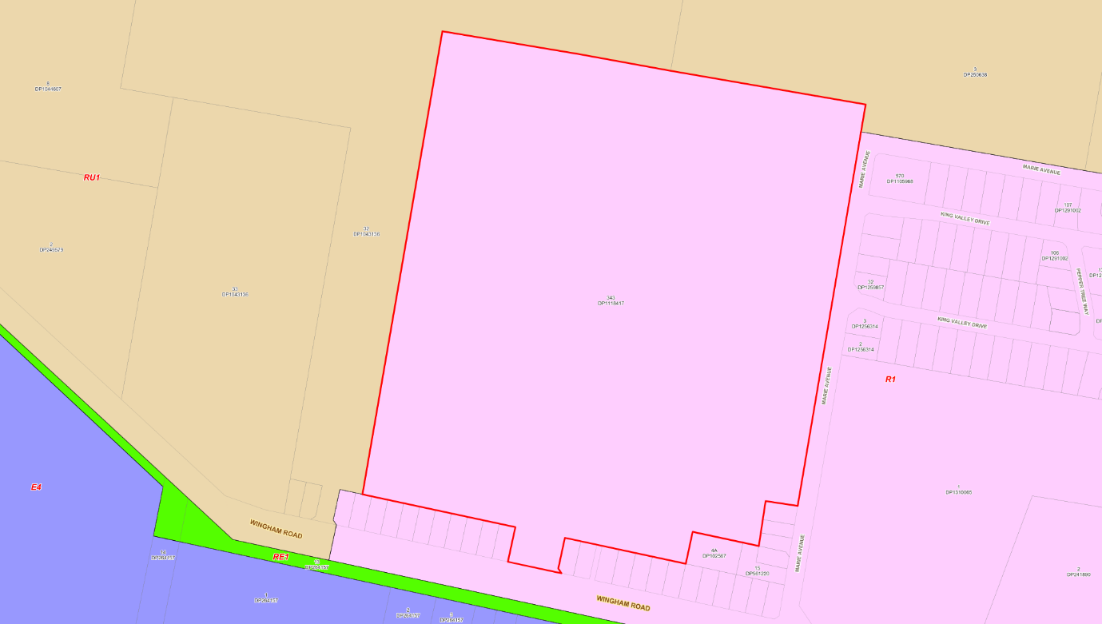

According to the definitions in Section 1.4 (contained in the Dictionary), the proposal satisfies the definition of Seniors Living which is a permissible use with consent in the Land Use Table in Clause 2.3.

The zone objectives include the following (pursuant to the Land Use Table in Clause 2.3):

- To provide for the housing needs of the community.
- To provide for a variety of housing types and densities.
- To enable other land uses that provide facilities or services to meet the day to day needs of residents.

The proposal is considered to be consistent with these zone objectives for the following reasons:

- The development contributes housing stock to meet the needs of the community.
- The development, whilst being a low-density scale, contributes housing variety (seniors housing) to meet the needs of the community.

General Controls and Development Standards

The LEP also contains controls relating to development standards, miscellaneous provisions and local provisions. The controls relevant to the proposal are considered in Table 4 below.

Table 4: Consideration of the LEP Controls
Clause | Comments
Part 2 Permitted or Prohibited Development
2.7 Demolition requires development consent | The development involves the demolition of existing structures located on the site. Conditions of consent relating to demolition have been included.
Part 4 Development Standards
4.3 Height of Buildings | The development proposes single storey dwellings across the whole development which are all below the permitted height limit of 8.5m.  Details of the dwellings associated with Stage 1 have been provided which demonstrates compliance with the height of building standard with dwellings ranging in height between 3.8m and 5.1m.  Concept ridge levels have also been provided for subsequent stages which demonstrate that all of these dwellings are capable of complying with the height of building standard. Whilst this will be further considered under future applications, it is demonstrated under this application that compliance can be achieved and a Clause 4.6 variation will not be required to conform with the concept DA provisions under this application.  - Max: 8.50m  - Proposed: 5.10m
4.4 Floor Space Ratio | The development conforms to the floor space ratio development standard. The development as a whole has a floor space ratio of 0.10:1 which is below the permitted 0.6:1.  - Max: 0.6:1  - Proposed: 0.10:1
Part 5 Miscellaneous provisions
5.10 Heritage conservation | The proposed development is not located within a heritage conservation area or within proximity to any items of heritage.  A basic AHIMS search (ID# 938268) was conducted, and the search reveals no known items of aboriginal cultural heritage located within proximity to the proposed development.
Part 7 Additional land provisions
7.3 Earthworks | Extensive earthworks are proposed to be undertaken as part of the development to facilitate appropriate areas to accommodate the built form, parking areas and access roads.  The development has been reviewed against the necessary matters for consideration under Section 7.3(3). The earthworks are not considered to result in unreasonable visual impacts on the streetscape or adjoining lands. There will be no adverse impact on drainage patterns, soil stability or environmentally sensitive areas.  The development can be supported subject to appropriate conditions of consent to mitigate any potential impacts associated with erosion and sediment run off.
7.11 Essential services | The proposed development will be adequately serviced by reticulated water, sewer, electricity and road access.

The proposal is considered to be generally consistent with the LEP.

- Section 4.15 (1)(a)(ii) - Provisions of any Proposed Instruments

The Draft MidCoast Local Environmental Plan has been the subject of public consultation under the EP&A Act, and is therefore relevant to the proposal.

Under the provisions of the Draft MidCoast LEP, the site retains the same zonings. Seniors housing remains permitted with consent in the R1 zone. The proposal is consistent with the relevant zone objectives.

There are no development standards or provisions of the Draft MidCoast LEP that would warrant amendment to, or prohibit, the development.

- Section 4.15(1)(a)(iii) - Provisions of any Development Control Plan

The Greater Taree Development Control Plan 2010 (DCP) is relevant to the application.

The aims of the Plan are to ensure good quality, sustainable development outcomes that maintain a high level of environmental amenity. The Plan is designed to allow flexibility in the application of its controls where strict compliance is considered unreasonable or unnecessary provided the relevant objectives of the Plan have been achieved.
The following is a summary of the evaluation of the proposal pursuant to the relevant provisions of the Plan.

Greater Taree Development Control Plan (DCP) 2010
Part B – Character Statement
Comment: The character statement for Taree is yet to be drafted. Noting this however, the development is considered to be compatible with the surrounding character and the intended future character for the area.

Part D – Environmental
Comment: The development satisfies the relevant objectives and performance criteria of Section D. Conditions of consent in relation to erosion and sediment control will be imposed.

Part G – Car Parking & Access
Comment: The development satisfies the relevant objectives and performance criteria of Section G. The specific matters are outlined below:

Part G1 – Car Parking and Access:
The development complies with the performance criteria of G:
- Car parking spaces are not located within 3.0m of the road alignment.
- Garage widths are at least 3.0m. Conditions of consent requiring all access and parking to be in accordance with AS2890.1 will be imposed.
- The development has a compliant driveway which exceed the 4.0m requirement. The development will be conditioned to require a driveway application. The final width of the driveway will be determined at this stage. The development can comply with the required width.
- Hardstand areas have been minimised and landscaping has been implemented across the site.

Part G1.1 – Location of Driveways:
The driveway associated with the development is appropriately located on the site and is clear of all obstructions and allows adequate visibility for vehicles entering and exiting the site. The development complies with the relevant performance criteria of G1.1. Conditions of consent requiring compliance with AS2890.1 will be imposed.

G1.2 Service Vehicle Requirements:
The applicant has demonstrated that the internal road network is capable of permitting appropriately sized service vehicles (including waste service trucks) to manoeuvre throughout the site. With regards for Stage 1, the internal road network along with the existing road network are capable of permitting the safe movement of service vehicles.

G1.3 Parking Requirements for Specific Land Uses:
The development proposes a mixture of three-bedroom units and two-bedroom units. Accordingly, the development provides each three-bedroom unit with two (2) spaces and the two-bedroom units are provided with one (1) covered space. The number of spaces satisfies the requirements of Part G1.3. Whilst later stages of the development provide visitor parking, it is noted that the driveway for each unit can accommodate a visitor parking (stacked in front of the garage) which is considered appropriate and does not impact on pedestrian amenity. Further consideration of parking requirements will be undertaken as part of the assessment of subsequent stages, however it is considered that there is appropriate parking indicated on the concept plans.

G1.4 Car Parking Requirements:
The parking spaces have been correctly calculated.

Part H – Residential
Comment: The development satisfies the relevant objectives and performance criteria of Section H. The specific matters are outlined below:

Note: It is noted that a number of the development controls within Part H are covered under the provisions of SEPP (Housing) 2021. To avoid confusion or doubt, consideration of Part H has been undertaken, but where a control conflicts or is duplicated within the SEPP, the SEPP has prevailed and taken priority.

Part H2.1 Site Coverage and Lot Requirements:
The development does not exceed the permitted 65% site coverage.

Part H2.2 Building Setbacks:
No zero lot line setbacks are proposed as part of the development.

Part H2.3 Building Height:
The development complies with the objectives and performance criteria pf Part H2.3. The development has a maximum height of 5.1m which is below the permitted 8.5m. The development also does not exceed three (3) storeys.

H2.4 Car Parking and Access:
The development complies with the objectives and performance criteria pf Part H2.3. Specifically, the following is noted:
- The garages do not dominate the frontage.
- The driveways for Stage 1, are considered appropriate to facilitate the suitable access to the units.
- Hardstand areas have been minimised and landscaping has been implemented across the site.
- The design or parking and access has been appropriately considered by the designer. The development will be required to comply with AS2890.1.

Part H2.5 Private Open Space:
The development has been designed to achieve practical compliance with the performance criteria of H2.5.

Part H2.6 Solar Access and Overshadowing:
The development complies with the relevant objectives and performance criteria of Part H2.6. The units have been orientated to maximise north facing solar access.

Part H2.7 Acoustic and Visual Privacy:
The development complies with the relevant objectives and performance criteria of Part H2.7. The units have been appropriately designed to minimise the risk of impacts to acoustic and visual privacy. This is also a consideration under the Seniors Housing Design Guide.

Part H2.8 Views:
No views are impacted by the development. The development is considered satisfactory having regards for the objectives and performance criteria of Part H2.8.

Part H2.9 Safety, Security and Entrances:
The development generally complies with the relevant objectives and performance criteria of Part H2.9. The following is noted:

- The development is designed to include units that face the street frontage.
- All entrances to each unit are considered to be easily identified.
- Each unit has covered access to the front door.

Part H3.4 Multi Dwelling Housing:
He development is generally compliant with the relevant objectives and performance criteria of Part H3.4 as noted below:

Site Coverage:
The lot size exceeds 1,000m².

Setbacks:
The units under Stage 1 are setback 5m which is below the required setback of 7m. Whilst being less than the required 7.0m the setback is considered appropriate having regards for the broader locality and the streetscape. The units present as duplexes as opposed to a large built form and are single storey only. The reduced setback is considered appropriate and allows for suitable landscaping and street amenity. It is noted that under the Seniors Housing Design Guide, there are no prescribed setback controls, and instead it places emphasis on streetscape amenity. Noting this, it is considered that the setbacks provided are appropriate and can be supported.

Car Parking and Access:
Each unit has appropriate parking required. Each three-bedroom unit has two (2) spaces, and the two-bedroom unit has one (1) space. Visitor parking spaces have also been provided throughout the development as well as facilitated within each driveway. The development proposes driveways of suitable width for each unit.

Private Open Space:
Each unit is considered to be provided with sufficient private open space. It is noted that consideration of open space is also outlined through SEPP (Housing) 2021 and consideration of this is discussed elsewhere. Noting this, whilst not strictly conforming to the controls for private open space, the development is considered to provide appropriate levels of private open space for each unit, noting that the intended occupants as well as the provision of communal open space within the development as well.

Storage:
Sufficient storage space has been provided for each unit.

Part M – SWMM
Comment: The development has been reviewed against the relevant provisions of Part M. The development is considered to be satisfactory having regards for the applicable objectives and performance criteria and can be supported.

A Waste Management Plan has been submitted in support of the application. The Plan adequately addresses waste management procedures associated with the demolition, construction and the ongoing management of the site.

The provision of domestic waste storage and collection was raised and has been appropriately addressed. Consultation with Council’s Waste Services team has been undertaken and support for the development has been provided. Council’s Waste Service team have reviewed the waste management plan and noted that there is sufficient space for the manoeuvring of waste vehicles, suitable space for collection areas and the details provided can conform with council requirements and regulations with regards for waste collection.

Part N – Landscaping
Comment: The development satisfies the relevant objectives and performance criteria of Section N. The specific matters are outlined below:

Part N1.4 Dual occupancy, multi-dwelling housing, residential flat buildings and mixed use development

The application has been supported by a landscape plan. The development is considered to be compliant with the performance criteria associated with Part N1.4 as follows:

- The development is considered to result in a suitable outdoor space which will contribute to a high level of amenity for occupants.
- Planting is considered appropriate for the site and locality and will provide a high level of amenity to the occupants as well as improving the overall streetscape.

- Section 4.15(1)(a)(iiia) – Planning agreements under Section 7.4 of the EP&A Act

There have been no planning agreements entered into and there are no draft planning agreements being proposed for the site.

- Section 4.15(1)(a)(iv) - Provisions of Regulations

Consideration has been given to the relevant provisions prescribed by the regulations being:

- Section 61 – Additional matters that consent authority must consider

In accordance with Section 61, consideration of the demolition of the existing structures, has been undertaken. Appropriate conditions of consent have been imposed on the consent.

  - Section 4.15(1)(b) – Significant Likely Impacts of Development

The significant likely impacts of that development, including environmental impacts on both the natural and built environments, and social and economic impacts in the locality must be considered. In this regard, potential impacts related to the proposal have been considered in response to SEPPs, LEP and DCP controls outlined above and the Key Issues section below.

The consideration of impacts on the natural and built environments includes the following:

Context and setting
The development is located on the urban fringe of Taree and forms a transition between urbanised and semi-rural areas. The development has been designed to be sympathetic to both the natural and built landform and is considered to be compatible with the local character.

The development is located adjacent to a recently finalised residential subdivision, as well as adjacent residential dwelling along Wingham Road. The proposal maintains a low density, low scale proposal which is compatible with the adjoining development. Further to this, the development forms somewhat of an extension to the existing seniors housing development which is located on the opposite side of Marie Avenue. It is considered that this will provide a compatible streetscape and skyline for the surrounding area and also from higher vantage points within the broader locality.

The development has demonstrated through the plans and supplied reports that the proposal will be suitable having regards for context and setting and can be supported.

Access and traffic
Access to the development is proposed via two (2) access roads located off Marie Avenue. Internal access roads traverse the site to allow for occupants and visitors to navigate the site. Suitable parking is also provided within the site to cater for both residents and visitors.

The applicant has demonstrated that the road network to get access to the site is suitable and has capacity to cater for the proposal without the need for significant upgrade. Council’s Development Engineers have noted that the frontage of the site to Marie Avenue is not currently provided with kerb and guttering. Additional details for civil works were requested form the applicant. These details have been provided which demonstrate that the necessary upgrade works for kerb and gutter can be facilitated. These matters have also been conditioned.

The applicant has also demonstrated that all proposed internal access and parking within the development is compliant with the provisions of AS2890.1 and Planning for Bushfire 2019. Conditions of consent reflecting this will be imposed.

Overall, it is considered that the applicant has demonstrated that the development will not adversely impact on the road network and that it is suitable to cater for the intended traffic numbers. The development is considered to be suitable having regards for access and traffic impacts.

Streetscape/Visual Amenity
It is considered that the development forms a low scale expansion of the existing urban fabric associated with the area to the east. The development remains sympathetic to the existing character and presents dwelling designs which are contemporary whilst respecting the surrounding locality, including both the natural and built environments.

Dwelling facades provide appropriate variety and compatibility to avoid both a repeated or ‘staccato’ streetscape. Such situations can occur in other residential estates and seniors housing developments, where the streetscape can appear flat due to repeated design, or completely disjointed as designs do not complement each other. The applicant has provided a number of dwelling facades which demonstrates a common theme for the complex, whilst allowing for diversity and interest in the broader streetscape.

The spacing of the units combined with the landscaping, also contributes positively to improving the overall streetscape and visual amenity in the area. The applicant has demonstrated this through the plans which depicts conceptual streetscapes of the whole development, as well as detail streetscapes for Stage 1.

To this extent, it is considered that the development has appropriately configured the layout to maximise the opportunities of the site, whilst working within the limits of the site constraints. This is done without adversely impacting on the streetscape and utilises design features to lower the overall visual impact of the development. Overall, it is considered that the proposal has positively responded to the constraints on the site and has resulted in a development which sits within the broader locality without adversely impacting on the streetscape or overall visual amenity.

It is noted that visual impact and impacts to streetscapes were raised as a key issue by the panel during the initial briefing. This is further discussed in key issues.

Utilities
The development site is provided with all essential services and utilities, including electricity, stormwater, sewer and potable water. These services are able to be connected to the proposed development, however, may require upgrade. Where upgrades are required, these matters would be addressed through the construction phase and have been conditioned accordingly.

Flora and fauna impacts
Whilst the development proposes to utilise existing cleared areas for the development, it will however involve the removal and modification of some areas of vegetation. The application has been supported by a Biodiversity Development Assessment Report (BDAR), which was noted the areas of vegetation to be removed, along with vegetation management and mitigation actions to offset the impacts.

The BDAR notes that within the areas for vegetation removal, there are no threatened ecological communities and only one threatened bat species was identified as potentially impacted and subject to being offset. In addition to this the BDAR nominated a number of mitigation measures that had been implemented to avoid impacts, including the siting of the design and emphasis on maximising retention of vegetation and revegetating appropriate areas of the site. As a result of the impacts of the development, the BDAR has noted that a total of 17 ecosystem credits and 11 species credits (Southern Myotis) will need to be retired. The BDAR also concludes that there will be no serious and irreversible impacts and the proposal will not impact any ecological communities or threatened species under the Environmental Protection and Biodiversity Conservation Act 1999.

The application was also referred to DPE-Water for concurrence in accordance with the Water Management Act 2000, due to the works in proximity to the existing watercourse and riparian corridor. Support was provided by DPE-Water subject to general terms of approval. These have been incorporated as a condition of consent.

In summary the applicant has been able to demonstrate that the works will not unreasonably impact on the existing vegetation and will not result in serious or irreversible impacts. The applicant has demonstrated that mitigation measures can be incorporated to reduce the risk of tree damage during works, and revegetation of areas will be undertaken. The development is considered appropriate having regards for ecological matters and can be supported subject to appropriate conditions.

Natural hazards
The site is partially mapped as bushfire prone land. The application was supported by a bushfire report, which was referred to NSW Rural Fire Service for consideration in accordance with Section 100B of the Rural Fires Act 1997. The application was supported by NSW RFS with general terms of approval (GTA) being issued in conjunction with their Bushfire Safety Authority. These GTAs have been included as conditions of consent.

Safety, security and crime prevention
The development is considered to be designed to meet CPTED principles and provides appropriate casual surveillance across, and within, the site as well as into the public domain.

Economic and Social Impacts
It is considered that the development will result in net positive social and economic impacts. Specifically, the following is noted:

Social Impacts: The development provides additional housing to cater for the needs of an ageing population. The development provides ageing persons with housing in an area that affords them independent living whilst allowing them to age in place, with assisted care increasing as necessary. Additionally, it places ageing persons in proximity to other ageing persons, which will contribute to increased social benefits through personal connections, interactions and a shared community.

Economic Impacts: The development will result in both short-term and long-term economic benefits. Short-term benefits result from the increase in economic activity during the construction phase through the employment of construction workers, and the possible flow on effects of economic activity form these works (in the event they are transient workers).

Long-term benefits include additional population growth for the area and the economic activity that this would contribute to in both the surrounding area as well as the broader LGA. Additionally, the inclusion employment of staff within the seniors housing complex will provide employment opportunities on a permanent basis in the locality.

Overall, it is considered that, on balance, the development results in positive social and economic impacts and can be supported.

Site design and internal design
The development is considered to be suitably designed to allow the safe movement of both pedestrians and vehicles within the proposal. Clear separation between vehicle access and pedestrian access has been established to assist with this. Further to this, the plans demonstrate that the site will be completely accessible for all residents, including those utilising wheelchairs.

The configuration of the independent living units is considered appropriate for the ongoing use by future occupants, whilst minimising potential impacts on adjoining properties. In addition to this the residential units (including circulation spaces) have been appropriately configured to provide appropriate living conditions that do not adversely impact the occupants or adjoining properties. The units have also demonstrated that they can be adaptable to meet the differing needs and requirements of ageing persons.

Overall, the development is considered to be suitably designed to allow for the safe use of future occupants.

Construction
Construction activities associated with the development have the potential to result in impacts on the surrounding area and adjoining developments.

Conditions of consent have been imposed to address these potential impacts and includes construction hours, erosion and sediment control, waste management, demolition, construction management, and traffic management.

Cumulative impacts
The combination of any of the impacts identified in this report are not considered to result in any cumulative impacts which would warrant the modification or refusal of the application.
Accordingly, it is considered that the proposal will not result in any significant adverse impacts in the locality as outlined above.

  - Section 4.15(1)(c) - Suitability of the site

Based on the assessment contained within this report, the development appropriately responds to the site constraints and opportunities. The site's attributes are conducive to supporting the development when considering the road network, topography, and existing infrastructure. The development has established a layout that is compatible with the broader locality and sits within the area's landscape.

In summary, the development has adequately addressed the site limitations and opportunities, and, all things considered, the site attributes are conducive to supporting the development.

  - Section 4.15(1)(d) - Public Submissions

Submissions are considered in Section 5 of this report.

  - Section 4.15(1)(e) - Public interest

The development satisfactorily addresses Council’s criteria and would provide a development outcome that, on balance, would result in a positive impact for the community. Approval of the development would be in the public interest.

- DEVELOPER CONTRIBUTIONS

In accordance with councils Greater Taree Section 94 Contributions Plan 2016 the development is required to pay contributions associated with the proposed development. As the development is for a concept application, contributions will be calculated at the time of application for each stage. Noting this, the contributions for Stage 1 have been calculated as part of this application.
The contributions for Stage 1 are based on the number of units and bedroom configuration of each unit. Accordingly, there is a total of 19 units, being 17 two-bedroom units and two (2) three-bedroom units. There is also a credit for the existing lot.
The development is located within the ‘Taree-Cundletown’ local contributions catchment. The contributions for the development are identified in the below table:
Table 5: Contribution Amounts - Derived from January 2026 Figures
Taree – Cundletown Local Catchment
Catchment Facilities | Contribution
Taree-Cundletown | $11,701.44
Greater Taree Facilities | $53,532.90
Total | $65,234.34

- REFERRALS AND SUBMISSIONS

  - Agency Referrals and Concurrence

The development application has been referred to various agencies for comment/concurrence/referral as required by the EP&A Act and outlined below in Table 5.

There are no outstanding issues arising from these concurrence and referral requirements subject to the imposition of the recommended conditions of consent being imposed.

Table 7: Concurrence and Referrals to agencies
Agency | Concurrence/  referral trigger | Comments  (Issue, resolution, conditions) | Resolved
Integrated Development (S 4.46 of the EP&A Act)
RFS | Section 100B - Rural Fires Act 1997 | The proposal is for a Seniors Housing development on bushfire-prone land, which is defined as a ‘special fire protection purpose’ and therefore the application triggers an ‘integrated approval’ pursuant to Section 100.b of the Rural Fires Act 1997.  The application has been referred to the NSW RFS for comment. The NSW RFS has issued a Bush Fire Safety Authority supporting the application.  The application has satisfied the requirements under the Rural Fires Act 1997. | Y
DPE - Water | Section 91 – Water Management Act 2000 | The application proposes works within mapped watercourses and requires a Controlled Activity Approval.  The application was referred to the Department of Planning and Environment - Water pursuant to Section 91 of the Water Management Act 2000 No 92.  The Department of Planning and Environment - Water has issued general terms of approval supporting the application.  A Controlled Activity Approval will be required prior to the commencement of works within the watercourse. This will be imposed as a condition of consent. | Y

  - Council Officer Referrals

The development application has been referred to various Council officers for technical review as outlined in the table below:

Table 8: Consideration of Council Referrals
Officer | Comments | Resolved
Development Engineering | Council’s Development Engineering team reviewed the application having regards for traffic impacts and stormwater management.  Concerns were initially raised through the assessment with two requests for additional information being issued to the applicant in relation to additional road upgrade works and amendment and further details on stormwater calculations and design. Amendments to the required plans and reports were conducted by the applicant and resubmitted to Council for assessment.  The assessment by Development Engineering concluded that the application could be supported subject to appropriate conditions of consent being imposed. | Y
Building Services | Council’s Building Services team reviewed the application having regards for matters associated with National Construction Codes (NCC) and Building Codes of Australia (BCA) compliance. In addition to this the Building Services team also had consideration for conditions and requirements relating to building certification construction certificates.  The assessment by the Building Services team concluded that the application could be supported subject to appropriate conditions of consent being imposed. | Y
Ecology | Council’s Ecology team reviewed the application having regards for matters associated with impacts on flora and fauna as well as compliance with the relevant biodiversity legislation.  The assessment by the Ecology team concluded that the application could be supported subject to appropriate conditions of consent being imposed. | Y
Environmental Health | Council’s Environmental Health team reviewed the application having regards for land contamination.  Concerns were initially raised through the assessment in relation to land contamination and the details contained within the supplied reports. Amendments to the report was facilitated by the applicant and resubmitted to Council for assessment.  The assessment by the Environmental Health team concluded that the application could be supported subject to appropriate conditions of consent being imposed. | Y
Waste Services | Council’s Waste Services team reviewed the application having regards for waste management associated with the development.  Whilst no concerns were initially raised by the Watse Services team, additional information was requested by the Planning Panel to ensure that the development could appropriately manage waste on the site in accordance with council requirements.  As part of this a Waste Management Plan was requested form the applicant. This plan was supplied and subsequently reviewed by the Waste Services team.  The assessment by the Waste Services team concluded that the application could be supported without the need for the imposition of any conditions. They also noted that the ongoing management of the development would be required to comply with the provisions and required levies and charges as prescribed under the Local Government Act and Regulations. Conditions are not required to be imposed as these are a regulatory function of council under separate legislation. | Y
Water Services | Council’s Water Services team reviewed the application having regards for matters associated with water and sewer infrastructure and servicing.  The assessment by the Water Services team concluded that the application could be supported subject to appropriate conditions of consent being imposed. | Y
Water Quality | Council’s Water Quality team reviewed the application having regards for water quality associated with stormwater management.  Minor concerns were raised through the assessment in relation to the configuration and calculations for achieving water quality compliance. Amendments to the details were facilitated by the applicant and resubmitted to Council for assessment.  The assessment by the Water Quality team concluded that the application could be supported subject to appropriate conditions of consent being imposed. | Y

The outstanding issues raised by Council officers are considered in the Key Issues section of this report.
  - Community Consultation

The application as originally made was exhibited from 30 September 2024 to the December 2022 accordance with the Environmental Planning and Assessment Act 1979, Environmental Planning and Assessment Regulation 2021 and the MidCoast Council Community Engagement Strategy.

Council received zero (0) submissions during the community consultation process.

- KEY ISSUES

The following key issues are relevant to the assessment of this application having considered the relevant planning controls and the proposal in detail:

  - Streetscape and Interface with Adjoining Properties

Concerns were raised with the applicant during the initial briefing with the Planning Panel in relation to the visual impacts of the development on the surrounding area, including the residential properties and adjoining rural lands. Whilst some streetscape sections were provided, it was noted that the application lacked the necessary details to establish the impacts on the streetscape and all critical interfaces with adjoining properties.

The basis for this issue relates to the interaction of the development from a visual perspective, and how it would sit within the surrounding built form and landscape. Whilst some details had been provided which showed the streetscape along Marie Avenue, the plans did not demonstrate the interface to other properties and also did not establish the built form for later stages (noting only details for the built form of Stage 1 had been provided).

To this extent, additional cross sections were sought from the applicant in relation to the site (at the critical interfaces), as well as conceptual details for the built form and number of storeys of independent units under future stages. These indicative buildings were required to be shown on the sectional views of the interfaces at boundaries.

In response to these concerns, the applicant submitted a number of additional cross sections through the site and nominated single storey construction for all future units. These details are considered satisfactory to address the concerns raised. Through the supplied details, the applicant has been able to demonstrate that there will not be any significant impacts on the streetscape or unreasonable impacts on the interfaces to adjoining properties. The development is considered to result in a low scale built form which sits within the broader landscape. The use of single storey units compliments the streetscape, and the low density of the proposal avoids the appearance of excessive bulk and scale. The cross sections demonstrate that the development will appropriately continue the existing urban fabric from the east, whilst allowing for a transition to the rural environment to the north and west, through unit spacing and increased landscaped areas.

Resolution: It is considered that the applicant has been able to appropriately address the concerns raised and demonstrate that the development will not significantly impact on the surrounding area.

  - Waste Management

Whilst not initially raised as a concern by Council’s Waste Services team, the Planning Panel noted a number of shortfalls in the applicant’s details in relation to how waste would be managed on the site during its operation. Thes issues related to how the management of waste would conform to Council requirements and standards for waste management and collection form the site.

As a result of the concerns raised by the Planning Panel, the applicant prepared a Waste Management Plan in consultation with Council’s Waste Management Team.

The Waste Management Plan nominates an appropriate means for a tiered system in which residents will take their household waste (including general waste, recyclables, as well as provision for future food organics) to a waste point which is located in close proximity to their unit. From this point, the waste bins would be collected by maintenance staff and taken to the bulk collection point on site. Council’s waste service provider will the collect the bins from this location for transport off site to the appropriate waste facility.

The Waste Management Plan has been reviewed and supported by Council’s Waste Service team.

Resolution: The issue has been resolved and satisfies council requirements for waste management of the development.

- CONCLUSION

This development application has been considered in accordance with the requirements of the EP&A Act and the Regulations as outlined in this report. Following a thorough assessment of the relevant planning controls, issues raised in submissions and the key issues identified in this report, it is considered that the application can be supported.

It is considered that the key issues have been resolved satisfactorily through amendments to the proposal and/or in the recommended draft conditions at Attachment A.

- RECOMMENDATION

That the Development Application DA2024/0680 for a 207 Unit Seniors Housing Development at Lot 343 DP 1118417, 55 Marie Avenue, Taree be APPROVED pursuant to Section 4.16(1)(a) or (b) of the Environmental Planning and Assessment Act 1979 subject to the draft conditions of consent attached to this report at Attachment A.

The following attachments are provided:

- Attachment A – Draft Conditions
- Attachment B – Plans
- Attachment C – Staging Plan
- Attachment D – Civil Plans
- Attachment E – Stormwater Strategy
- Attachment F – Biodiversity Development Assessment Report
- Attachment G – Bushfire Report
- Attachment H – Concept Road Work Plans
- Attachment I – Contamination Report
- Attachment J – Geotechnical Report
- Attachment K – Traffic Impact Assessment
- Attachment L – Waste Management Plan
- Attachment M – SEPP (Housing) 2021 - Schedule 4 Compliance Table

